**Final Project Analysis Report**

**JinZhang & Chung-Yang Li**

**The following materials contain the evidences and Screen Shots of our conclusion about the Neural Network Project.**

**Implementation**

First of all, we download MNIST handwritten digital dataset for training. The download data is an idx file, hence we implement the “IdxReader”.java to read the file contains 60000 handwriten digit images and labels to further train our neural network.

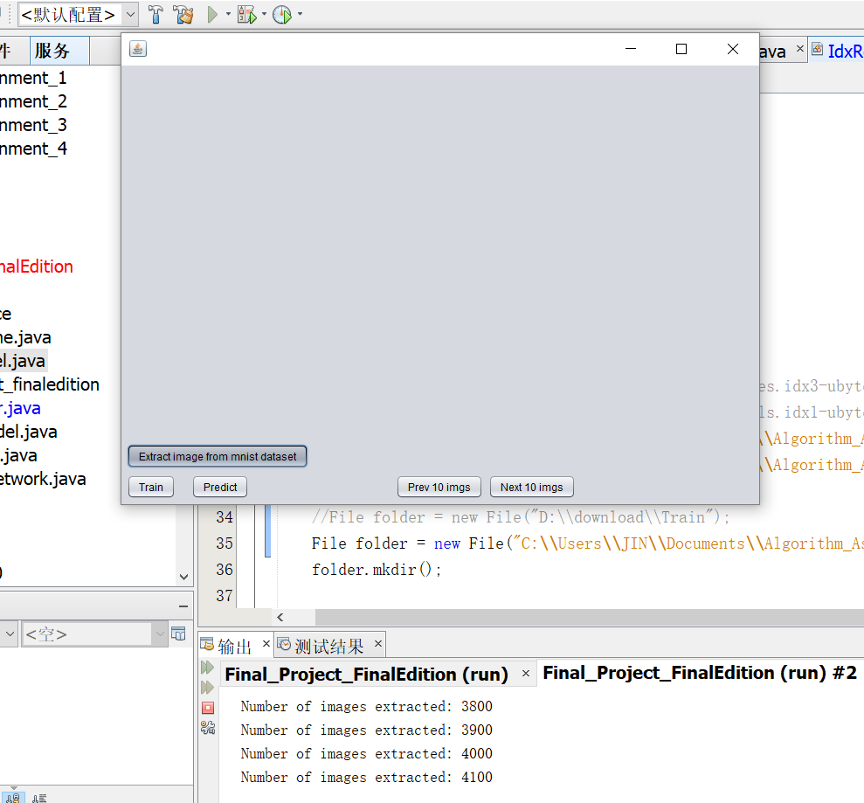

When click the button, the button’s “action performed function” is to extract the images from the file.

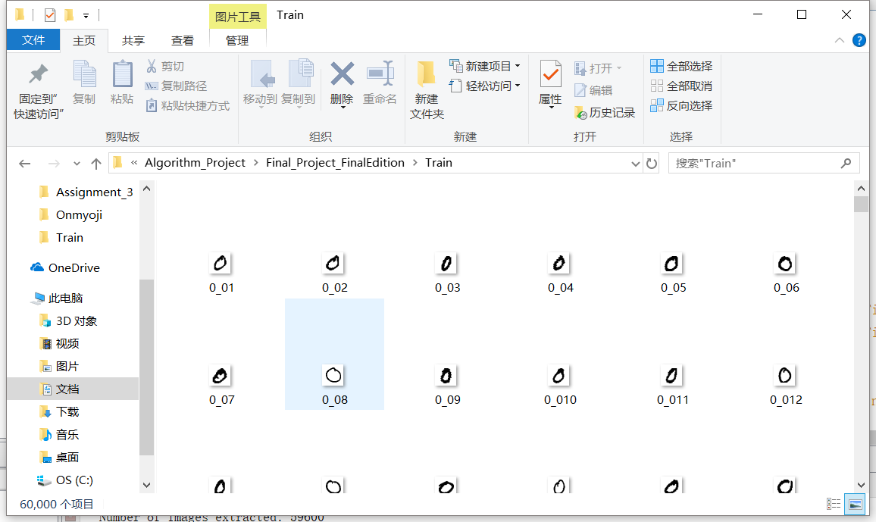 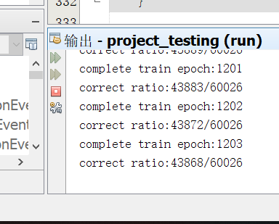

Because the data size is too large which contains 60000 images, when we first use those images to train the neural network it cost 18 hours to run the project. However, right after the training was completed, one of the bugs popped out. Therefore, we decided to decrease the training dataset, we use 500 images to train the network.

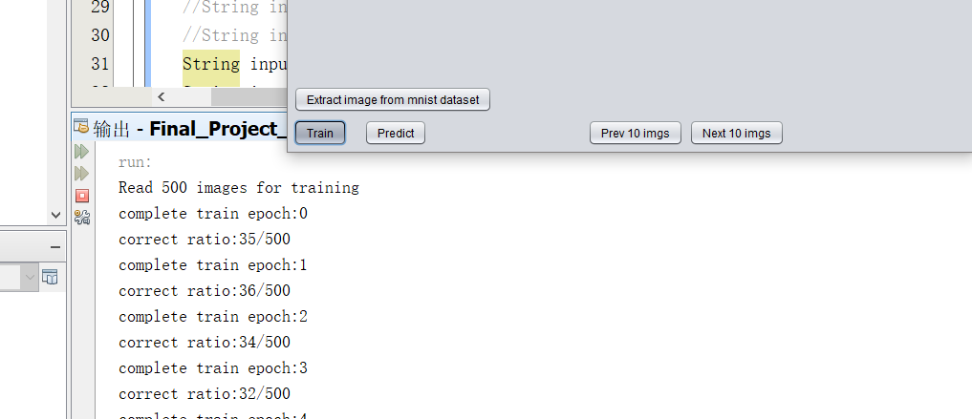

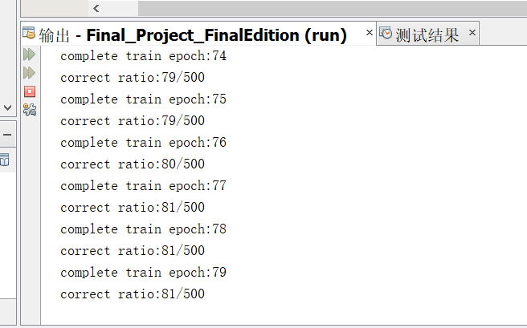

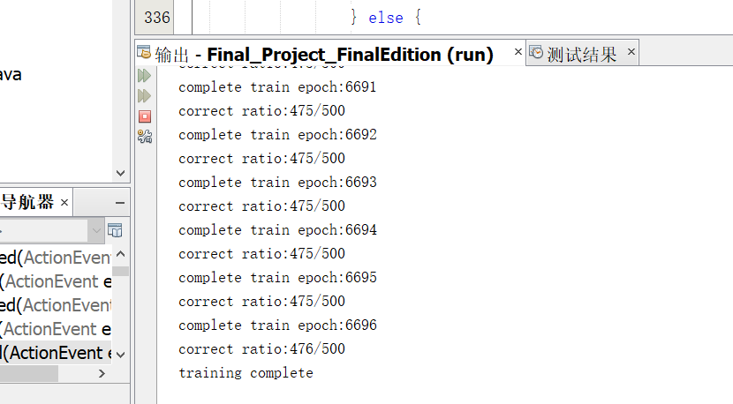

The correct ratio continues to rise until the full training process is completed.

After training, we can click the predict button to test the neural network’s accuracy based on digit images from other source. The outcome of the neural network will show in the Output panel. And we also have ten icons to show the outcome too.

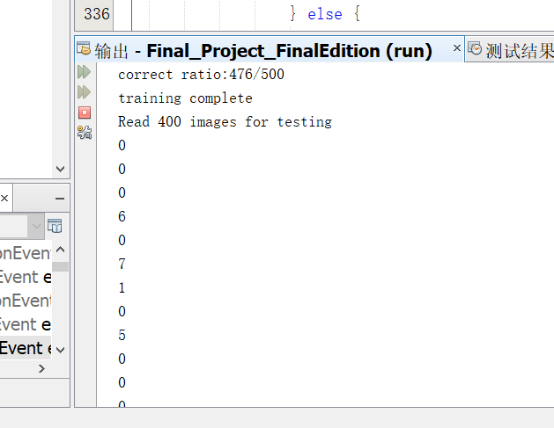

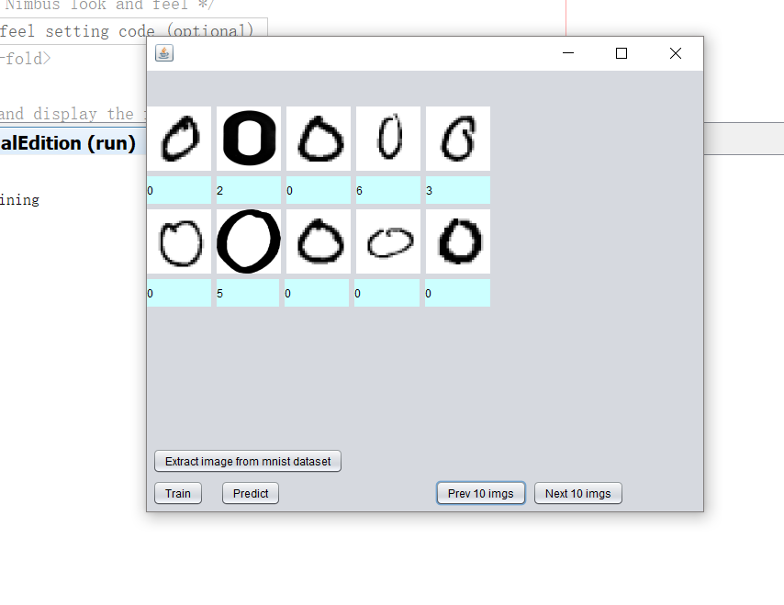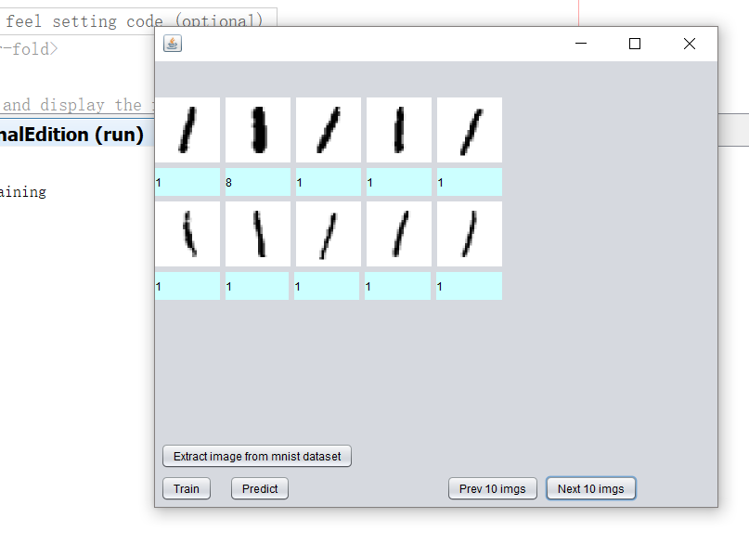

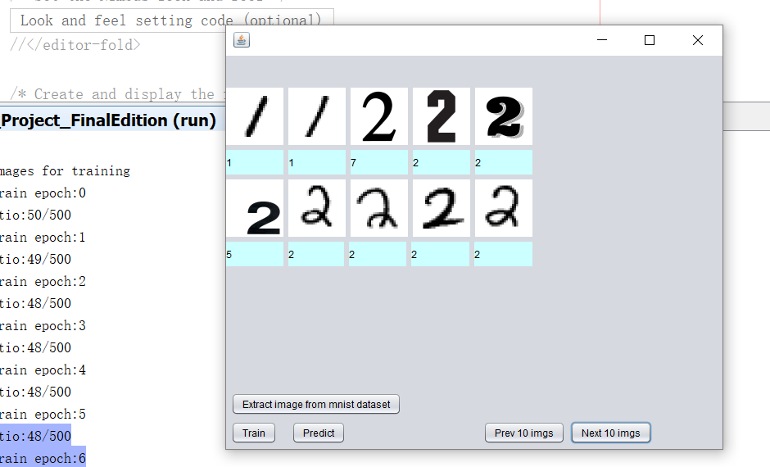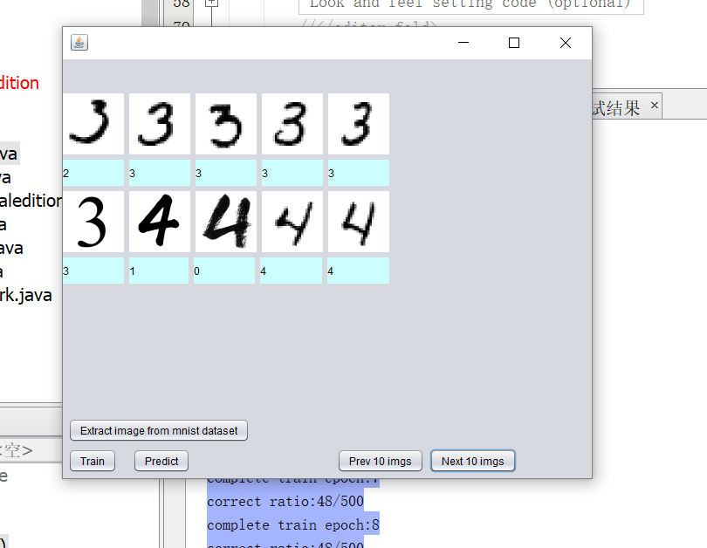

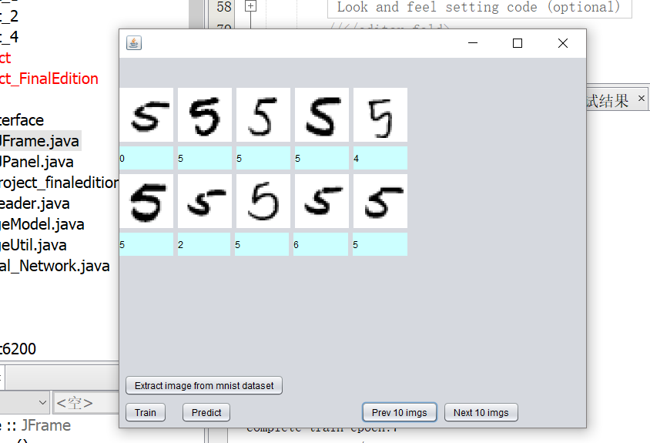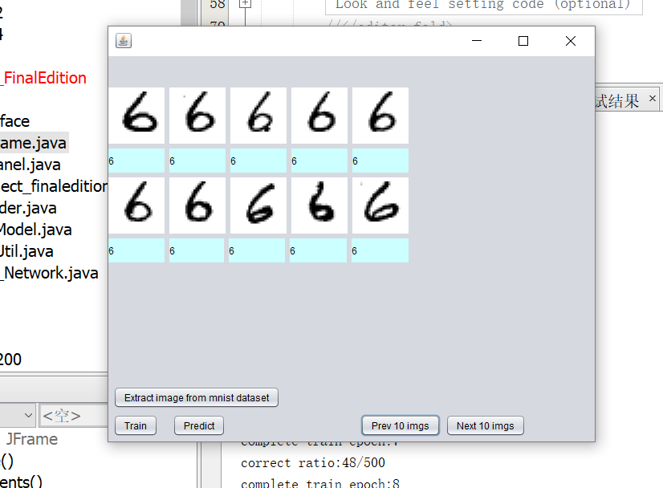

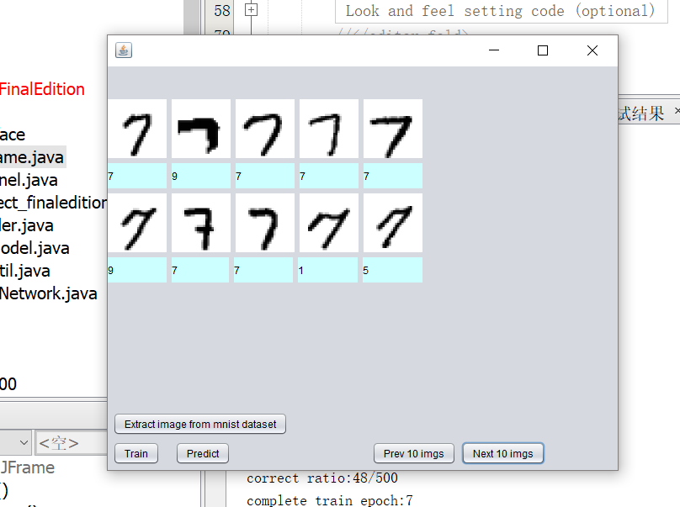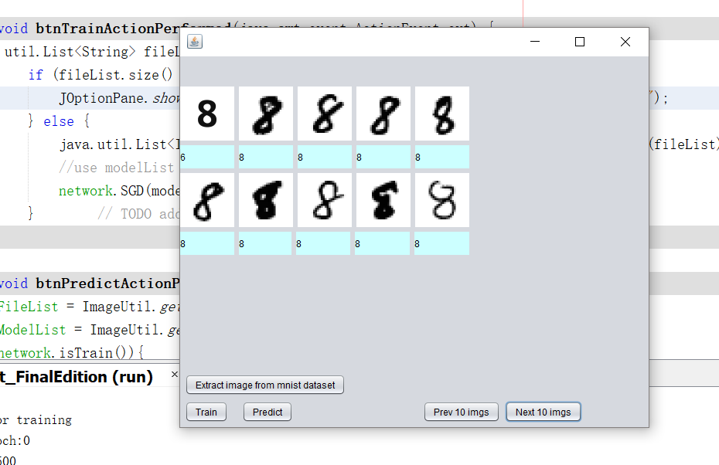

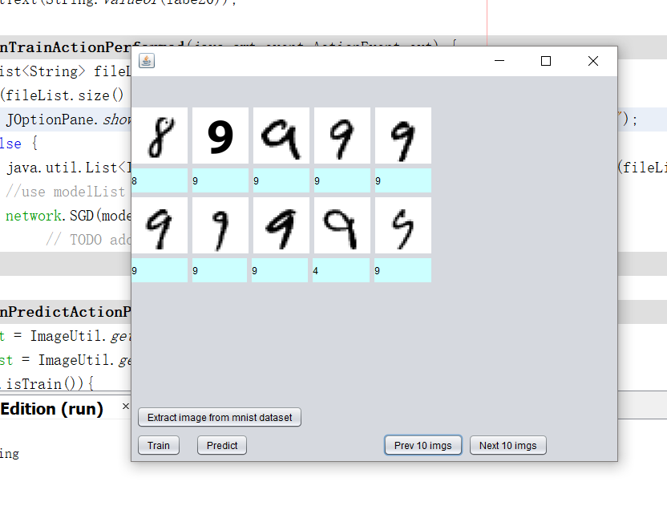

The outcome is not 100% correct. But the correct ratio is as high as 95%, which means the neural network accurately identify digital data.

**Conclusion**

In conclusion, we find the neural network algorithm work as we expected and very interesting. There is a lot of ways to implement it, and so much improvement could be made. With other constraints and optimization, this algorithm will help dealing with various kinds of recognizing problems.

In the end, I am very grateful to the professor and TA for the academic help.

And my hardworking teammates.

**Reference**

http://neuralnetworksanddeeplearning.com/chap1.html

https://github.com/tammypi/neuralnetwork-sample